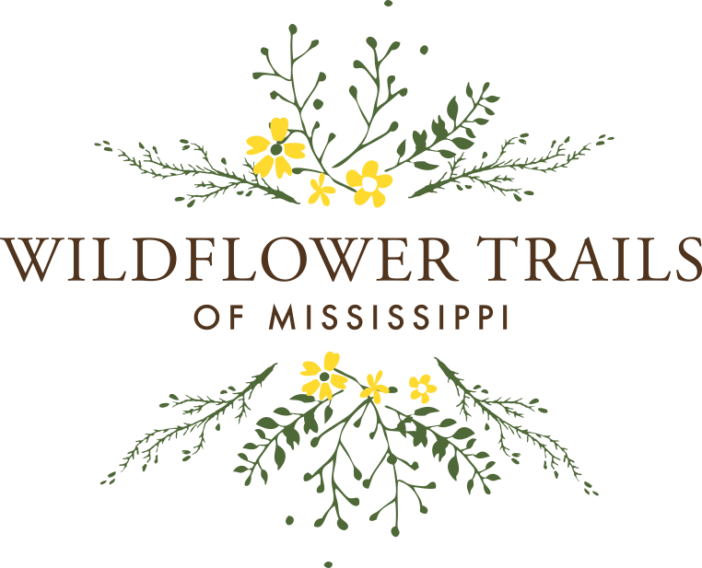
The Wildflower Trails of Mississippi is a project founded by Keep Mississippi Beautiful, the state’s nonprofit for litter cleanups, recycling, and beautification. KMB launched the project in 2015 to help our state with beautification, conservation, ecotourism and helps restore pollinators and pollinator habitats.


To join the Wildflower Trails of Mississippi and request wildflower seed, we ask you to utilize MSU Extension’s Publication 3000 planting guide (located on our website, mswildflowers.org). sarah@keepmsbeautiful.com, 601-853-4210.
Name of project leader(s).
Phone numbers and emails:
Estimated date of project:
Location of site & photo of site. _________________
Estimated size of plot. _________________________

By completing this form we commit to completing the reporting details requested. The seed requested is being provided by Keep MS Beautiful through our USDA Wildflower Trails of Mississippi program.

Date seed provided:
Quantity: Estimate 7 lb per acre




- Herbicide application or other treatments used. Please provide details which will help us learn for future projects. Feel free to use additional pages.

- Tillage procedure and date. Some people use a no till drill.

- Planting date and type of planting used. (Often hand casting works the best due to seed size.

- Photos of phases through the project.

